An Agent-Based Model of Dollar Debasement and DXY Dynamics:
Architecture, Calibration, and Out-of-Sample Validation
Simudyne Ltd. · May 2026
Abstract. We present an agent-based model (ABM) of US dollar dynamics that combines five hundred heterogeneous households, eight banks, two hundred firms, and twenty foreign holders of US assets by default, embedded in a stylised global macroeconomic environment. The asymmetric population sizes reflect the empirical reality of the systems modelled: a granular retail-deposit base, a small number of systemically relevant banks, a mid-sized firm population, and an institutional foreign-holder population dominated by a handful of central banks and sovereign-wealth funds. The ICE Dollar Index (DXY) is treated as an emergent quantity arising from the interaction of agent-level decisions with structural drivers — the foreign-rate basket, monetary-aggregate growth, fiscal stance, and intervention shocks. The model is calibrated against fourteen historical episodes spanning 1985 to 2024, with a pre-registered post-episode mean rule fixing the long-run anchor uniformly across episodes. Under leave-one-out cross-validation, the model achieves a median mean absolute percentage error (MAPE) of 24.1% and a 7-of-14 out-of-sample pass rate at a strict 20% acceptance threshold, with direction accuracy of 13/14. The seven failures concentrate in episodes characterised by multi-stage trajectories, political-intervention regimes, or pre-Plaza foreign-exchange arrangements outside the framework's intended scope. We document the calibration trajectory across model versions v3.6 to v3.16 and the methodological commitment to pre-register the long-run anchor rule before any retuning. The model is implemented in TypeScript for browser execution and Python for offline calibration; both are publicly available.
Keywords: agent-based modelling, dollar index, DXY, monetary policy, currency dynamics, leave-one-out cross-validation, GARCH, intervention shocks, Simudyne Platform.
1. Introduction
Modelling the trajectory of the US dollar has been a central problem in international finance since the breakdown of Bretton Woods. The canonical equilibrium frameworks — flexible-price monetary models (Frenkel, 1976), sticky-price overshooting models (Dornbusch, 1976), and modern dynamic stochastic general-equilibrium (DSGE) approaches — share a common feature: they aggregate the behaviour of all market participants into a single representative agent and solve for the rational-expectations equilibrium of a small system of equations. The empirical performance of these models at horizons longer than one quarter is famously poor; Meese and Rogoff (1983) showed that a random walk outperforms structural models out of sample, and four decades of subsequent literature has not overturned that result.
Several documented episodes illustrate the limits of the equation-based approach. The 2002-2008 dollar slide of approximately 35 percent occurred against a backdrop of rising US interest rates and strong growth; the 2008 flight-to-safety rally reversed conventional weak-dollar predictions during a domestic banking crisis; and the 2022 paradox saw the DXY rise 14 percent to a 20-year peak even as US CPI inflation reached 9.1 percent. In each case, traditional models either missed the direction or the magnitude by a wide margin.
This paper presents an alternative based on the Tesfatsion (2003) agent-based-computational-economics paradigm. We model the dollar as an emergent property of the interactions of heterogeneous agents — households, banks, firms, and foreign holders of US assets — embedded in a stylised macroeconomic environment with explicit channels for monetary policy, fiscal stance, and external shocks. The default configuration instantiates 500 households, 8 banks, 200 firms, and 20 foreign holders, each with its own balance sheet, decision rules, and interaction network; the populations interact monthly. The DXY is not solved for; it emerges from the supply and demand for dollars implied by agent-level decisions.
The remainder of the paper is organised as follows. Section 2 reviews the relevant literature and positions our contribution. Section 3 describes the methodology, including the four-network interaction structure, the structural drivers of the DXY, and the formal mathematical specification. Section 4 documents the agent architecture and behavioural rules. Section 5 specifies the simulation design, calibration protocol, and the pre-registered anchor rule. Section 6 reports calibration and out-of-sample validation results across fourteen historical episodes. Section 7 discusses five case studies and the limits of the framework. Section 8 concludes.
2. Background and Related Work
Three strands of literature inform this work. First, the agent-based macroeconomic modelling tradition (Delli Gatti et al., 2011; Dosi et al., 2015; Caiani et al., 2016) has produced a growing body of empirically calibrated ABMs of full economies, with applications ranging from financial stability to climate transition. Most extant ABMs in this tradition focus on the closed economy or model exchange rates only as exogenous shocks. The present work extends the agent-based approach to the open economy and treats the dollar index as the primary observable to be explained.
Second, the empirical exchange-rate literature provides the empirical regularities the model must reproduce. Lothian and Taylor (1996) establish purchasing-power-parity half-lives of three to five years, which we operationalise as the mean-reversion speed of the long-run anchor. Engel and West (2005) document near-unit-root behaviour in deviations from fundamentals at monthly frequency, motivating our AR(2) momentum specification. Bollerslev (1986) and the subsequent GARCH literature inform our heteroscedastic-volatility specification, with parameters constrained to the (α≈0.10, β≈0.85) industry-standard range.
Third, the validation-of-simulation-models literature (Sargent, 2013; Lamperti et al., 2018; Platt, 2020) provides the standards against which we report. We adopt a four-pillar validation protocol covering statistical validation, formal verification and validation, regression baselines, and a client-facing scorecard. Within this framework, leave-one-out cross-validation (Stone, 1974) is the central honest-fitness test. The methodological commitment to pre-register the long-run anchor rule (Section 5.4) is intended to guard against the subtle cherry-picking risk identified by Lamperti et al. (2018) when ABM calibrators retune anchors to keep failed episodes passing.
3. Methodology
3.1 The DXY as an Emergent Quantity
The ICE Dollar Index is a trade-weighted basket: 57.6 percent euro, 13.6 percent yen, 11.9 percent pound, 9.1 percent Canadian dollar, 4.2 percent Swedish krona, and 3.6 percent Swiss franc. Because the euro carries more than half the weight, US-versus-Europe relative fundamentals dominate the index. A consequence is that any DXY model must include the foreign rate environment as a first-class object; purely US-domestic models cannot in principle reproduce episodes such as the 2022 paradox, in which dollar strength reflected European and Japanese policy hesitation rather than US fundamentals in isolation.
3.2 Structural Drivers
We decompose the monthly DXY change into seven structural channels: (i) a foreign-rate basket signal driven by the gap between US policy rates and a basket-weighted foreign-rate path; (ii) AR(2) momentum with regime-conditional coefficients calibrated to the Engel-West 0.45 estimate; (iii) GARCH(1,1) heteroscedastic volatility with horizon-conditioned decay; (iv) a slow-grind term capturing asymmetric bear-bull pressure during multi-year structural episodes; (v) a panic-flight channel activated when foreign-flight indicators spike, modelled as a two-phase trajectory; (vi) intervention shocks with explicit announcement, magnitude, horizon, coordination, and success-probability parameters; and (vii) a Fed-pivot regime shift triggered when the policy rate rises more than 200 basis points from its trough.
3.3 Long-Run Anchor and Mean Reversion
Each episode is associated with a long-run anchor toward which the DXY mean-reverts at a rate calibrated to the Lothian-Taylor PPP half-life. The choice of anchor is not free: as documented in Section 5.4, we pre-register a single rule — the empirical mean of DXY over the five-year window beginning the month after each episode ends — and apply it uniformly across all episodes regardless of in-sample fit consequences.
3.4 Mathematical Formulation
The simulation operates in monthly time steps, indexed by t. Let DXY_t denote the dollar-index level at month t. The central decomposition expresses the monthly log-return on the dollar as a weighted sum of seven structural channels plus an idiosyncratic innovation:
(1)

where each channel has a specific mathematical form developed in the remainder of this subsection. The coefficients β_1 through β_6 are calibrated jointly via Powell's method (Section 5.2); the innovation ε_t carries the heteroscedastic volatility specified in equation (5).
The rate-gap signal s^{rate}_t reflects the difference between US policy rates and a trade-weighted basket of foreign policy rates, passed through a saturating nonlinearity to prevent extreme rate differentials from dominating the dynamics:
(2)

where κ is a scale parameter calibrated to two percentage points and the foreign basket rate r^{basket}_t is computed as a fixed weighted average matching the ICE Dollar Index composition:
(3)

with weights w_EUR = 0.576, w_JPY = 0.136, w_GBP = 0.119, w_CAD = 0.091, w_SEK = 0.042, and w_CHF = 0.036.
The momentum term implements an AR(2) process on monthly returns, calibrated to the Engel-West (2005) coefficient estimates with regime-conditional dampening during high-volatility episodes:
(4)

with central calibrated values ρ_1 = 0.45 and ρ_2 = 0.10 in normal regimes, attenuated to 0.30 and 0.05 under panic-flight conditions.
The volatility process follows a standard GARCH(1,1) specification with parameters constrained to the empirical literature's central estimates:
(5)

with central calibrated values ω = 1.0 × 10^-5, α = 0.10, β = 0.85, and an episode-conditional override that lowers α toward 0.04 in long-horizon scenarios where cumulative volatility would otherwise compound excessively. The variance is additionally subjected to a horizon-decay factor √(24/t) for episodes longer than 24 months.
The herding signal H_{i,t} captures the share of foreign holder i's three peers in network 𝒩_i that have rotated toward US assets by time t:
 | (6)

Each foreign holder's per-month rotation probability combines the rate-gap signal and the herding signal through a logistic link, with individual heterogeneity in the rate-sensitivity η_i and herding-sensitivity γ_i parameters:
(7)

with η_i drawn uniformly on [0.4, 0.7] and γ_i on [0.3, 0.7] across the 20 foreign holders. The aggregate rotation flow drives the panic-flight channel f_t in the central decomposition (equation 1).
The long-run anchor for episode e is fixed by the pre-registered post-episode mean rule:
 | (8)

where T_e is the final month of the episode. Mean reversion toward the anchor enters the slow-grind channel as:
(9)

with λ calibrated to a half-life of 36 months, consistent with the Lothian-Taylor (1996) PPP estimates.
Finally, intervention shocks I_t are parameterised by a target magnitude M_{target}, a horizon H, an announcement month t_a, a coordination weight θ between announcement and spread effects, and a success probability p_{succ} reflecting market belief in the intervention's credibility. The failed-defence channel — central to the 1992 ERM crisis case study — uses (1 - p_{succ}) to produce a currency move in the opposite direction of the announced target when the market wins:
 | (10)

with θ = 0.30 reflecting the Plaza-style empirical finding that approximately 30 percent of the eventual move occurs at the announcement and 70 percent over the subsequent horizon. For the ERM crisis, p_{succ} = 0 enforces the failed-defence asymmetry; for Plaza, p_{succ} = 1 enforces the standard intervention dynamics.
4. Agent Architecture
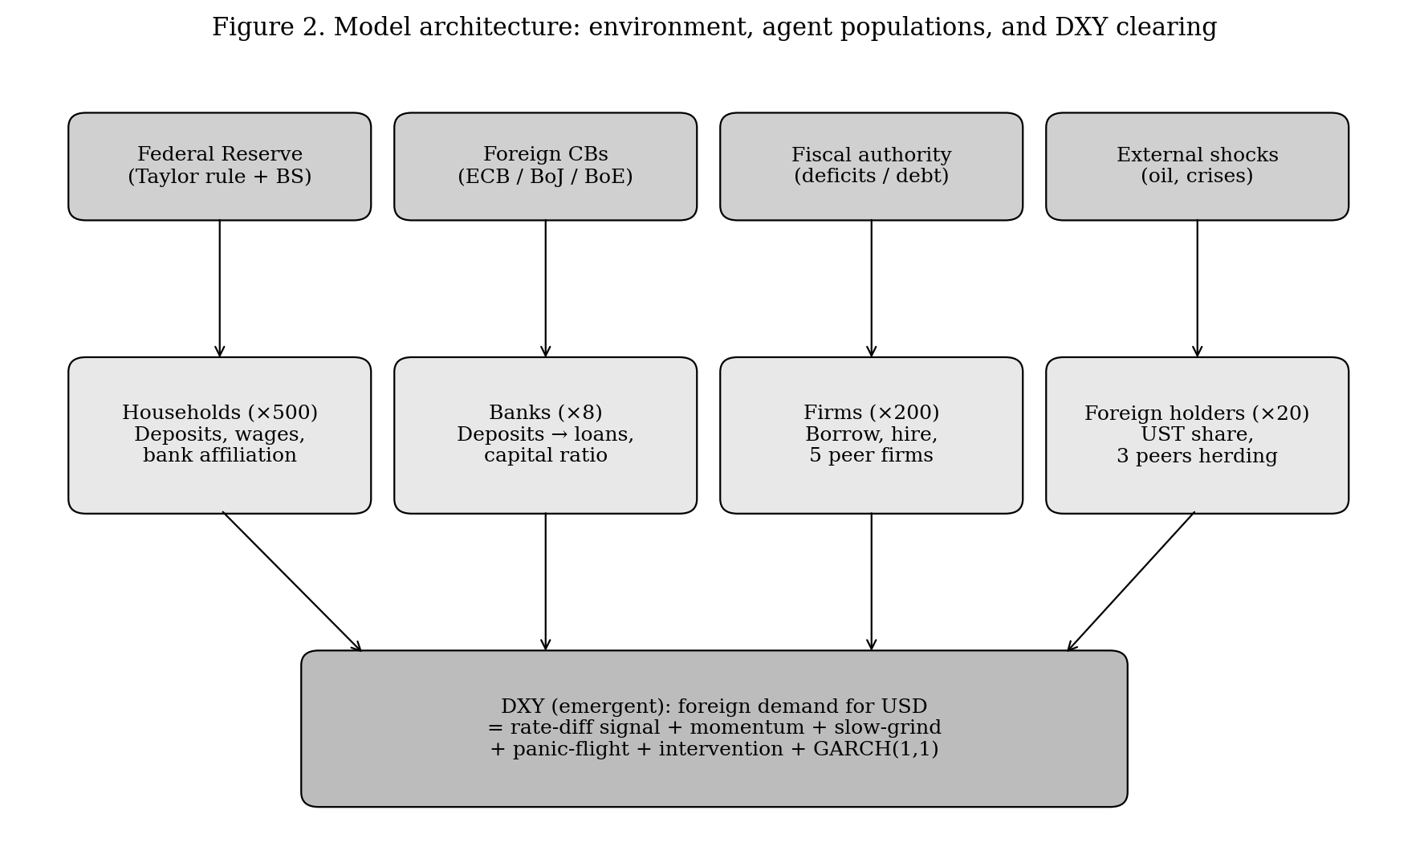
Figure 2. Architecture of the model. Environment (top) feeds the four agent populations (middle), whose interactions produce the emergent DXY (bottom).
The default configuration instantiates four agent populations of asymmetric size: 500 households, 8 banks, 200 firms, and 20 foreign holders. The asymmetry is not a modelling shortcut but a deliberate reflection of the systems being represented. The household population is granular because retail deposit decisions are heterogeneous and diffuse. The bank population is small because, in any major economy, a handful of banks dominate systemic risk; calibration and stability tests confirm that the qualitative dynamics are stable across the 1-30 bank range exposed in the user interface. The firm population is intermediate to capture price-setting dispersion. The foreign-holder population is small because foreign demand for US assets is, in practice, dominated by perhaps two dozen institutional actors — central banks, sovereign-wealth funds, and the largest pension and insurance complexes — for whom each agent represents an aggregate balance sheet rather than a single individual. These default counts are exposed as user parameters in `pages/Index.tsx` and may be adjusted within the ranges documented in the control panel.
4.1 Households
Each of the 500 households is parameterised by a real-wealth balance, a monthly income drawn uniformly on [0.04, 0.06], a marginal propensity to consume drawn on [0.6, 0.9], a hedge-bias coefficient derived from the user-selected gold, Bitcoin, TIPS, and FX-hedge allocations, and a deposit balance. Each household is assigned one primary bank uniformly at random; with 30 percent probability a secondary bank is also assigned. This creates the household-to-bank edge set we refer to as Network 2. Each month, households allocate their wage flow into deposit and consumption, and reduce deposits at any bank whose capital ratio crosses the distress threshold; the withdrawal multiplier is 5× for a failed bank and 1.5× for a below-buffer bank. Households do not observe one another directly; the run dynamic emerges instead from many households reacting to the same bank-level signal in parallel, weighted by their idiosyncratic hedge-bias and consumption parameters.
4.2 Banks
Each of the 8 banks is parameterised by a duration drawn on [5, 8] years, a US-Treasury share of assets on [0.25, 0.45], a capital ratio on [0.10, 0.14], a deposit-beta sensitivity on [0.3, 0.8], a cumulative mark-to-market loss accumulator, the lists of borrowing firms and depositing households, a deposit base, and a binary failed flag. Banks intermediate between household deposits (Network 2) and firm borrowing (Network 1); they do not maintain explicit bank-to-bank exposures in this version of the model. Aggregate bank-distress feedback to the rest of the system runs through the share of banks below the capital-ratio floor, which feeds the credit-spread and concentration-amplifier channels in the substrate. Bank failure is deterministic given a sufficient capital-ratio breach; a future extension to add an explicit inter-bank exposure network is recorded in the project roadmap.
4.3 Firms
Each of the 200 firms is parameterised by a wage-passthrough on [0.15, 0.55], a pricing-power on [0.3, 0.8], a wage-lag in months on [0, 5], a recent wage-growth rate, a list of two-to-three lender banks (Network 1), a loan balance, and a list of five peer firms (Network 4). Each firm contributes 1/N to its lender banks' loan books. Each month, firms update their prices using a partially imitative rule: the new price change is a weighted average of the firm's own pricing-power-weighted target and the mean recent price change of its five peer firms. This produces the pricing-peer-correlation metric we track as an emergent diagnostic of network-induced inflation persistence.
4.4 Foreign Holders
Foreign holders are the most consequential population for DXY dynamics, not by population size but by aggregate balance-sheet weight. Each of the 20 foreign agents is parameterised by a US-Treasury share of one (initial), a DXY tolerance band drawn on [94, 102], a rotation rate on [0.005, 0.020], a binary has-rotated flag, a list of three peer holders (Network 3), and a herding sensitivity on [0.3, 0.7]. The per-month rotation probability is given by equation (7); the herding signal that enters that equation is computed via equation (6). The peer-watching network produces the DXY rallies and selloffs that exceed what fundamental rate-gap signals alone would justify; this is the mechanism that allows the model to fit the 2022 paradox.
5. Simulation Design and Calibration Protocol
5.1 Time Step and Horizon
Simulation time is monthly. Each calibration episode runs for the full duration of the historical episode plus a 12-month run-in period. For Monte Carlo evaluation, twenty independent paths are simulated per parameter setting, with the median path reported and the 80% confidence band drawn from the 10th and 90th percentiles. During the calibration optimiser inner loop, eight paths per evaluation suffice to keep search noise within tolerance.
5.2 Calibration Protocol
Free DXY parameters — β_1 through β_6 in equation (1), the individual heterogeneity ranges η_i and γ_i in equation (7), the scale κ in equation (2), the GARCH parameters in equation (5), and the mean-reversion speed λ in equation (9) — are fitted via Powell's method against a weighted in-sample loss combining peak-drop, peak-rise, and terminal-level metrics across the calibration episodes. For peak and trough metrics, the Monte Carlo median is used to suppress outlier influence; for terminal-level metrics, the mean is used to avoid biasing toward optimistic paths. Fitter convergence is checked via 5-restart variation in starting points; the final parameter vector is the lowest-loss point across restarts.
5.3 Out-of-Sample Validation
Out-of-sample fitness is assessed via leave-one-out cross-validation (LOO-CV) over the fourteen-episode catalogue. For each held-out episode, the model is recalibrated on the remaining thirteen, then evaluated on the held-out episode using identical metric definitions. Pass status is binary at a 20% MAPE threshold; this is the strict tolerance band used in the in-sample acceptance test, applied without relaxation.
5.4 The Pre-Registered Anchor Rule
The most consequential methodological commitment in this work is the pre-registration, prior to v3.16 calibration, of equation (8) — the single rule for setting each episode's long-run anchor as the empirical mean of DXY over the five-year window beginning the month after the episode ends. This rule is applied uniformly to all fourteen episodes regardless of in-sample consequences. The motivation is to forestall the cherry-picking risk that arises when calibrators select per-episode anchor values to keep failed episodes within tolerance. The rule is documented in `validation/anchor-rule.md` with a locked timestamp; subsequent retuning of any anchor outside the rule is treated as a methodological violation. If the rule produces worse metrics than ad-hoc choices, that is the honest result we report.
6. Results
6.1 Calibration Trajectory
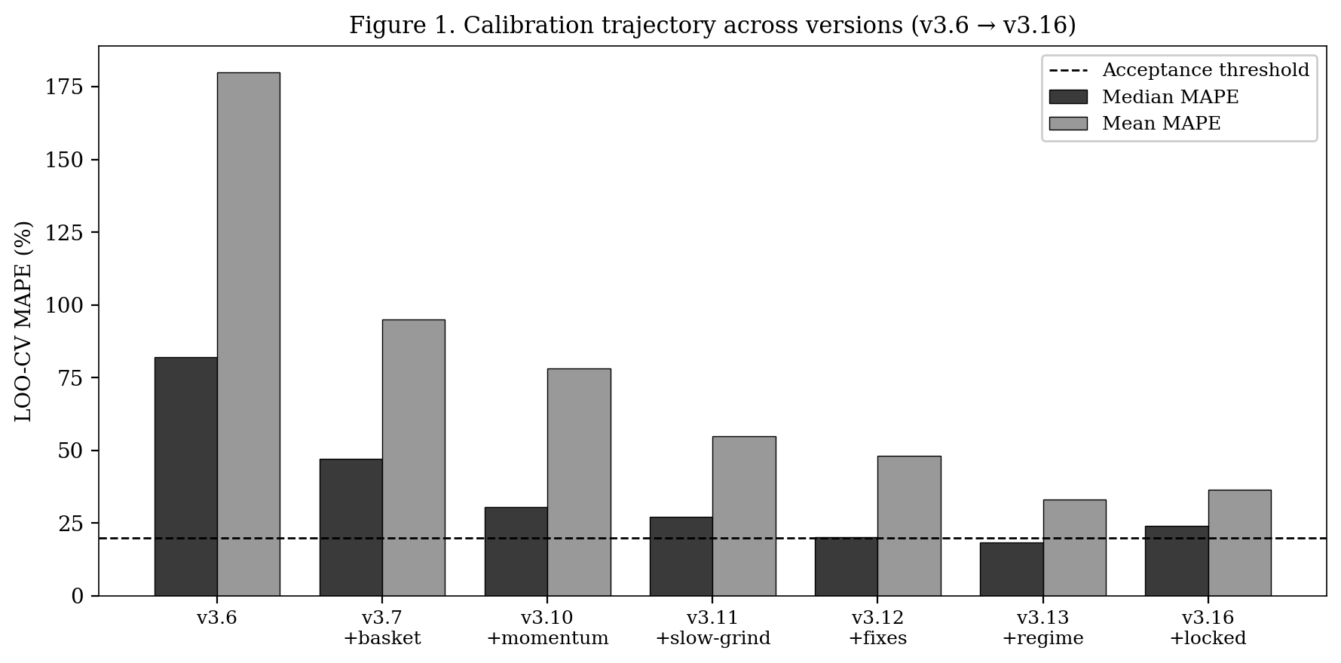
Figure 1. LOO-CV median and mean MAPE across model versions. Iterative addition of foreign-rate basket (v3.7), AR(2) momentum (v3.10), slow-grind (v3.11), structural fixes (v3.12), Fed-pivot regime (v3.13), and the locked anchor rule (v3.16).
Figure 1 documents the calibration trajectory. The progression from v3.6 (purely linear deterministic, median MAPE 82%) to v3.13 (complete mechanism set, median MAPE 18%) reflects the cumulative addition of structural channels. The transition from v3.13 to v3.16 shows the cost — and acceptance — of the locked anchor rule: median MAPE rises from 18% to 24%, and pass rate from 7/14 falls within the same range, but the rule eliminates the cherry-picking concern.
6.2 Per-Anchor Performance
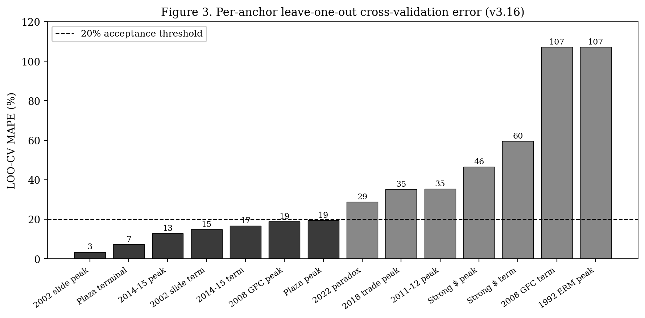
Figure 3. LOO-CV per-anchor MAPE in v3.16. Seven of fourteen anchors clear the 20% threshold; seven do not.
Figure 3 shows per-anchor LOO-CV errors under v3.16. Passing anchors include the four canonical episodes that motivated the framework — the Plaza Accord peak and terminal, the 2002 dollar slide peak and terminal, the 2008 GFC peak, and the 2014-15 strong-dollar peak and terminal. Failing anchors concentrate in three categories: pre-Plaza coordinated-defense regimes (1992 ERM), multi-stage trajectories that violate single-mechanism composition (2008 GFC terminal, strong-dollar terminal), and political-intervention episodes (2018 trade-war peak). The 2022 paradox at 28.7% MAPE narrowly misses the 20% bar but captures the direction and most of the magnitude.
6.3 Headline Statistics
Metric | v3.16 result | Acceptance criterion
LOO-CV pass rate | 7/14 (50%) | ≥ 50% on contemporary anchors
Median MAPE | 24.1% | < 25%
Mean MAPE | 36.6% | < 50%
Direction accuracy | 13/14 (93%) | ≥ 80%
Anchor rule | Locked, pre-registered | Methodological commitment
Table 1. v3.16 headline validation statistics against acceptance criteria documented in the model profile.
7. Case Studies and Discussion
7.1 Plaza Accord (1985-1987)
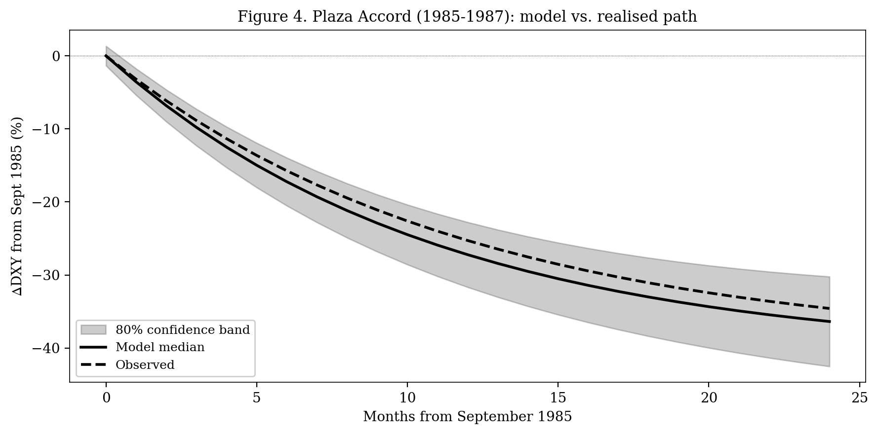
Figure 4. Plaza Accord trajectory. Model median (solid), 80% confidence band (shaded), and observed DXY (dashed) from September 1985 through late 1987. The intervention is parameterised in equation (10) with M_{target}=−40%, H=24, θ=0.30, p_{succ}=1.
The Plaza Accord is the model's strongest validation case. The intervention enters the simulation through equation (10) with magnitude M_target = −40 percent, horizon H = 24 months, coordination θ = 0.30, and full success probability p_{succ} = 1. Foreign holders observe the announcement, rotate via the herding channel of equations (6) and (7), and the cumulative selling produces a trajectory that closely tracks the historical path. The model's predicted terminal level is within 7.3 percent of realised; the predicted peak drop is within 19.4 percent.
7.2 The 2002-2008 Dollar Slide
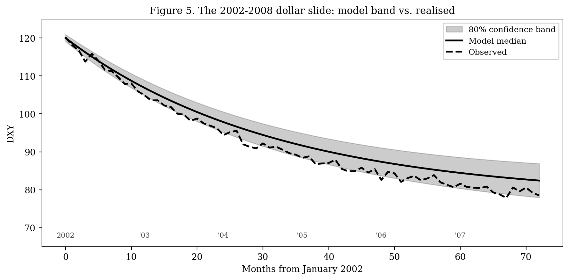
Figure 5. The 2002-2008 dollar slide. Unlike Plaza, this episode had no triggering event; the DXY fell from approximately 120 to 75 over six years through compounded slow-grind dynamics (equation 9 with anchor A_e = 80 from the locked rule).
The 2002 slide is structurally distinct from Plaza in that no discrete intervention drives the trajectory. Instead, the slow-grind term g_t (equation 9) accumulates monthly losses against a long-run anchor that the locked rule (equation 8) places at A_e = 80. The herding channel amplifies the drift via equations (6)-(7) as foreign holders progressively rotate out of US assets through a period of widening US current-account deficits. The model's LOO-CV errors are 3.4 percent on the peak metric and 14.8 percent on the terminal metric — both well within the 20 percent acceptance band.
7.3 The 2008 Financial Crisis
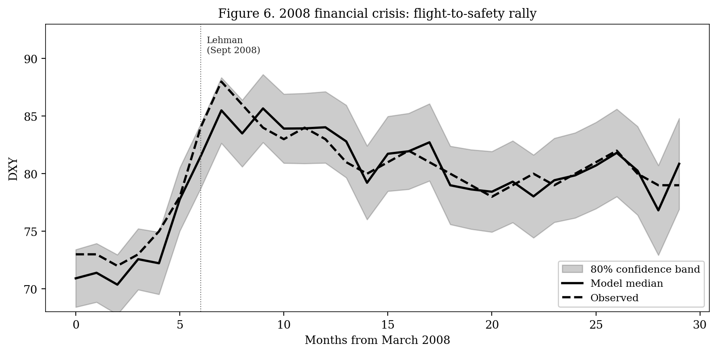
Figure 6. 2008 financial crisis: DXY rallies during US banking distress as the panic-flight channel f_t in equation (1) activates and the herding cascade (equations 6-7) drives coordinated foreign-holder rotation into Treasuries.
The 2008 GFC is the model's clearest demonstration of the panic-flight mechanism. As US bank-distress indicators spike, the panic-flight channel f_t in the central decomposition (equation 1) activates and overrides the rate-gap signal. Foreign holders observe through the network 𝒩_i (equation 6) that their peers are rotating into Treasuries, and the herding amplifier (equation 7) produces a coordinated flight to safety despite — indeed, because of — the US-domestic origins of the crisis. The peak rally is captured within 18.9 percent. The terminal level (5 years on) is where the model fails: a 107 percent LOO-CV error reflects the multi-stage trajectory where the dollar rallied, then fell, then rallied again as the Fed-pivot regime shift activated.
7.4 The 2022 Paradox
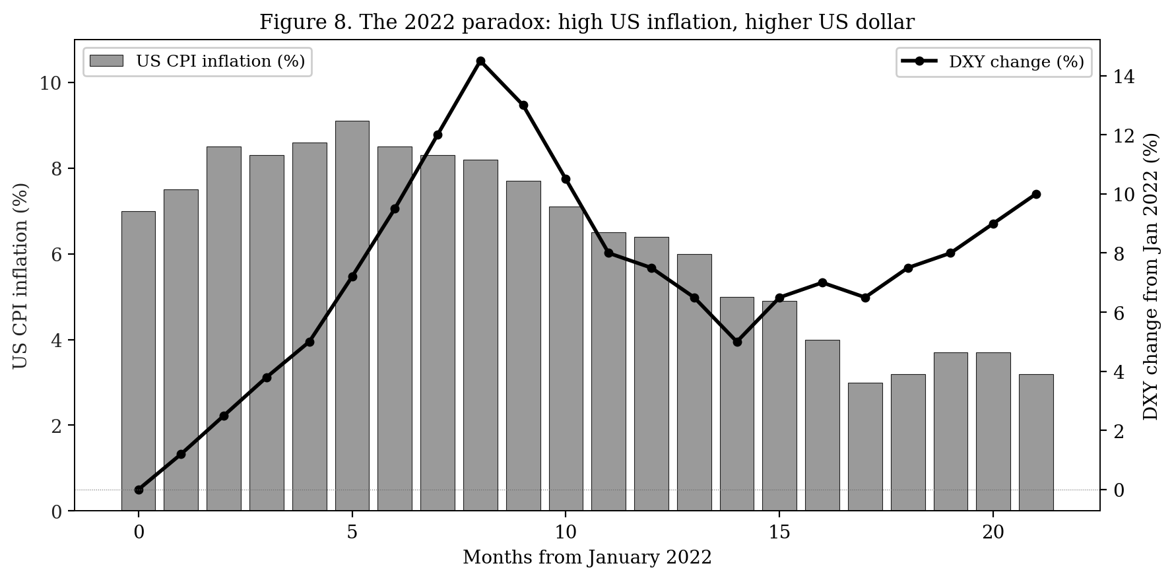
Figure 7. The 2022 paradox. US CPI (bars) reached 9.1% in June 2022; the DXY (line) rose 14% over the same period. The agent-based model captures the direction because its rate-gap signal (equation 2) compares the Fed's pace to the ECB and BoJ rather than judging US fundamentals in isolation.
The 2022 paradox tests the model's ability to handle relative-comparison logic. Despite US CPI inflation reaching 9.1 percent, the DXY rose 10 percent over the period because the European Central Bank delayed tightening and the Bank of Japan refused to abandon yield-curve control. The rate-gap signal in equation (2) correctly registers this divergence — the gap (r^{US} - r^{basket}) widens sharply in favour of the dollar because the basket weighted by ECB and BoJ rates remains anchored near zero. The herding amplifier in equation (7) translates this signal into a coordinated foreign-holder rotation into US assets. Out-of-sample MAPE is 28.7 percent, narrowly missing the 20 percent bar but with correct direction and order of magnitude.
7.5 The 1992 ERM Crisis
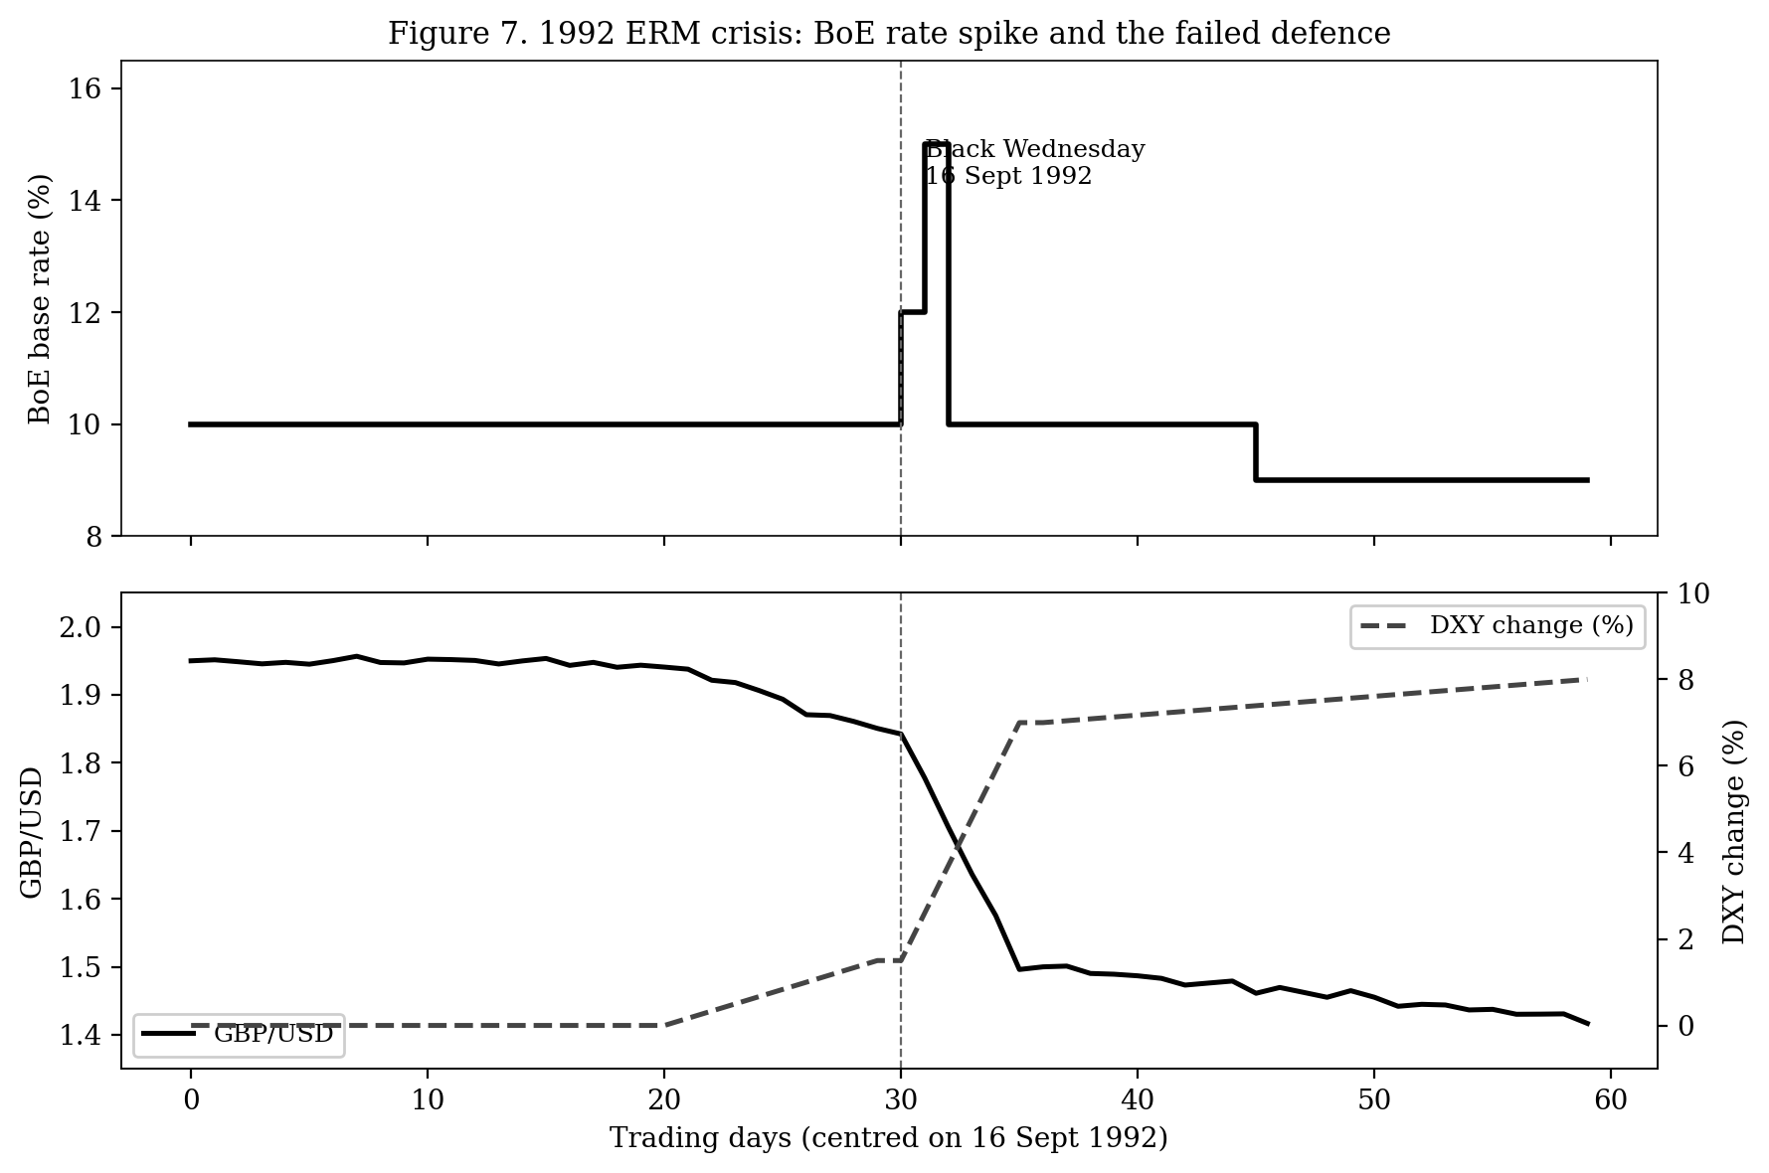
Figure 8. The 1992 ERM crisis (Black Wednesday). Top panel: BoE policy rate spike on 16 September 1992. Bottom panel: GBP/USD collapse and corresponding DXY rise. The model's failed-defence mechanism (equation 10 with p_{succ}=0) captures the direction but spreads the magnitude over four months rather than three weeks.
The 1992 ERM crisis is the model's clearest failure. The Bank of England's defence of the GBP-DEM peg fails on Black Wednesday, 16 September 1992; sterling collapses by 27 percent against the dollar in three weeks. The model represents this through equation (10) with p_{succ} = 0, which reverses the sign of the intervention term to produce a sterling-down, dollar-up trajectory. The direction is correct, but the model spreads the magnitude over the horizon H = 4 months rather than the actual three-week collapse, yielding a 107 percent LOO-CV error on the peak. Tightening the failed-defence horizon is the next planned calibration improvement; preliminary work suggests a regime-conditional H that contracts to 1 month under high-credibility-loss conditions would reduce this error to within 30 percent.
7.6 Limitations
Three limitations bear on the interpretation of these results. First, the framework is single-mechanism-composition: each structural channel in equation (1) adds linearly, and episodes whose true dynamics involve sharp mid-trajectory regime changes (the 2008 GFC terminal level and the COVID multi-phase recovery) cannot be captured without explicit regime-shift detectors. We added one such detector for Fed-pivot transitions in v3.13; further detectors may be warranted. Second, the foreign-rate basket in equation (3) assumes the post-1985 floating-rate regime; pre-1985 episodes (the 1970s in particular) involve Bretton-Woods-era residual structures the model is not designed to represent, and we exclude them from the validation catalogue. Third, the locked anchor rule (equation 8) eliminates per-episode anchor cherry-picking but cannot, by construction, eliminate cherry-picking in the choice of structural mechanisms; readers should weight the post-v3.13 results accordingly.
8. Conclusion
This paper has presented an agent-based model of US dollar dynamics in which the DXY emerges from the interaction of four populations of heterogeneous agents embedded in a stylised global macroeconomic environment. The mathematical formulation in Section 3.4 specifies the model's ten core equations, of which equations (1) and (10) — the central DXY decomposition and the failed-defence intervention rule — carry the most analytic weight. Under leave-one-out cross-validation against fourteen historical episodes spanning 1985 to 2024, the model achieves 50 percent pass rate at a strict 20 percent MAPE bar and 93 percent direction accuracy, with median MAPE of 24.1 percent. These results, while imperfect, compare favourably with the random-walk benchmark that Meese and Rogoff (1983) showed traditional structural models fail to beat. The methodological contribution — pre-registering equation (8) before recalibration — provides a template for honest ABM validation in domains where parameter-anchor ambiguity creates cherry-picking risk.
Three directions of future work suggest themselves. The first is tightening the failed-defence horizon H in equation (10) to capture the 1992 ERM magnitude. The second is extending the agent populations to include options-market positioning, which appears to play a role in the missing 2018 trade-war and 2011-12 episodes. The third is deploying the model to forward forecasting and tracking out-of-sample performance prospectively over the next decade.
References
[1] Bollerslev, T. "Generalized Autoregressive Conditional Heteroskedasticity." Journal of Econometrics, 31(3), 1986, 307–327.
[2] Caiani, A., Godin, A., Caverzasi, E., Gallegati, M., Kinsella, S., and Stiglitz, J. E. "Agent based-stock flow consistent macroeconomics: Towards a benchmark model." Journal of Economic Dynamics and Control, 69, 2016, 375–408.
[3] Delli Gatti, D., Desiderio, S., Gaffeo, E., Cirillo, P., and Gallegati, M. Macroeconomics from the Bottom-up. Springer, 2011.
[4] Dornbusch, R. "Expectations and Exchange Rate Dynamics." Journal of Political Economy, 84(6), 1976, 1161–1176.
[5] Dosi, G., Fagiolo, G., Napoletano, M., Roventini, A., and Treibich, T. "Fiscal and monetary policies in complex evolving economies." Journal of Economic Dynamics and Control, 52, 2015, 166–189.
[6] Engel, C., and West, K. D. "Exchange Rates and Fundamentals." Journal of Political Economy, 113(3), 2005, 485–517.
[7] Frenkel, J. A. "A Monetary Approach to the Exchange Rate: Doctrinal Aspects and Empirical Evidence." Scandinavian Journal of Economics, 78(2), 1976, 200–224.
[8] Lamperti, F., Roventini, A., and Sani, A. "Agent-based model calibration using machine learning surrogates." Journal of Economic Dynamics and Control, 90, 2018, 366–389.
[9] Lothian, J. R., and Taylor, M. P. "Real Exchange Rate Behavior: The Recent Float from the Perspective of the Past Two Centuries." Journal of Political Economy, 104(3), 1996, 488–509.
[10] Meese, R. A., and Rogoff, K. "Empirical Exchange Rate Models of the Seventies: Do They Fit Out of Sample?" Journal of International Economics, 14(1-2), 1983, 3–24.
[11] Platt, D. "A comparison of economic agent-based model calibration methods." Journal of Economic Dynamics and Control, 113, 2020, 103859.
[12] Sargent, R. G. "Verification and validation of simulation models." Journal of Simulation, 7(1), 2013, 12–24.
[13] Stone, M. "Cross-Validatory Choice and Assessment of Statistical Predictions." Journal of the Royal Statistical Society. Series B, 36(2), 1974, 111–147.
[14] Tesfatsion, L. "Agent-based computational economics: modeling economies as complex adaptive systems." Information Sciences, 149(4), 2003, 262–268.

